**Project 3 Planning Proposal**

***Team: Solo Project***

***Brief Description***

[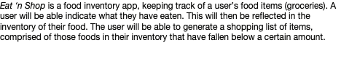](https://media.git.generalassemb.ly/user/40961/files/63ef2c80-b723-11ec-98cf-7fd4ab081ce9)

***Tech Stack***

React, Django  
New technology: Animate.css or React FramerMotion or some other CSS-related technology

***List of backend models and their properties***

GroceryData  
-groceryCurrent  
-groceryUsed  
-groceryUnitMeasure  
-groceryMinimum  
-groceryImageURL

***React component hierarchy (if applicable)***

logIn  
createGroceryInventory  
-addGroceryItem  
createGroceryUsedData  
-addGroceryUsed  
generateShoppingList

***User stories***

[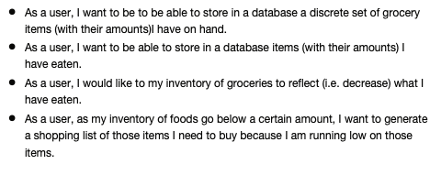](https://media.git.generalassemb.ly/user/40961/files/24294480-b725-11ec-9969-a4d09e1c7788)

***Wireframes***

[Wireframe.pdf](https://git.generalassemb.ly/SEI-124/project-3/files/3967/Wireframe.pdf)

***Anything else your squad lead should know***

I would like recommendations as to what tech configuration would be best for my proposal idea.